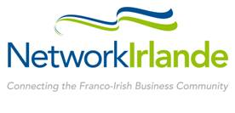
France Ireland
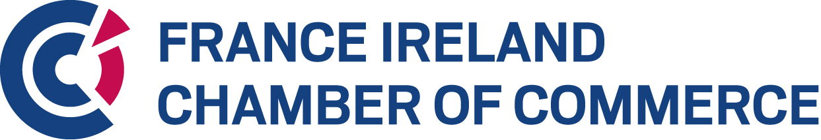
Business Awards 2020

ENTRY FORM

The annual Franco-Irish Business Awards recognising excellence in the economic relationship between Ireland and France

The Best Irish Company in France

Company Details

Name of Company _______________________________________________________________
Address______________________________________________________________________________________________________________________________________________________________________________________________________________________________________
Confirm that country of registration is Ireland by ticking this box
Company registration number: ________________
Name of CEO ___________________________________________________________________
Contact for the Awards ___________________________________________________________
Position ________________________________________________________________________
Telephone ___________________________Email______________________________________
Website ________________________________________________________________________

Business Profile
Describe your business in general. Include information in the table below on annual turnover, profit, and employees in the last two years (2018 & 2019) and projecting to 2020 (200 words). If you are a subsidiary of a larger group please fill in Group figures and if a stand-alone company please fill in figures for Irish Company.

 |  |  |  |  |  |  |  | Forecast
Group |  | Irish Company |  |  |  | 2018 | 2019 | 2020
(Tick box for information supplied) |  |  |  | Annual Turnover | €
 |  |  |  | EBIT | €
 |  |  |  | Employee Numbers

Description of business in general:

Financial Success
Demonstrate the overall growth in sales/profitability, and development of business activity in France (Years 2018, 2019 and projected 2020) (100 words)
 |  |  |  |  | Forecast
 |  |  | 2018 | 2019 | 2020
French | Annual Turnover | €
located | EBIT | €
Company
Info | Employees | Numbers

Indicate level of investment committed to the French market (employees, external consultants, office space....) (100 words)

Innovation
Describe the unique selling proposition of your product/service that has secured your success on the French market (200 words)

Employment – Current and Future
Present the employment strategy of your company into the future, supported by employment figures in Ireland and France, and a general overview of the employment policy (200 words)

Demonstrate that the company is a high-quality employer (working environment, employment benefits, HR management) (100 words)

Demonstrate that the employment between Ireland and France has increased positively from the viewpoint of both countries (100 words)

Please return completed Entry Form to info@franceireland.ie
All information received will be treated in confidence.
Companies who do not provide all the information on this entry form, including financial figures, will be excluded.
Please be aware that the content of the Entry Form will be the content by which your application will be judged.
Thank you for your nomination. Award recipients shall be selected by a jury in a 2-step Evaluation process, chaired by Eoin Scott (Motherboard).

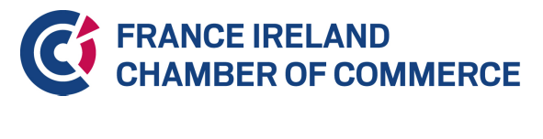
Corporate Social Responsibility
Describe your Company's commitment to CSR (200 words)

